Style Template – How to write a 6 Page Full Paper for IMWA 2012

Christian Wolkersdorfer¹, Mark Lund²

¹Cape Breton University, Industrial Research Chair in Mine Water Remediation & Management, PO Box 5300, Sydney, Nova Scotia, B1P 6L2, Canada, c.wolke@cbu.ca
² Mine Water and Environment Research Centre, Edith Cowan University, 270 Joondalup Drive, Western Australia 6027, Australia, m.lund@ecu.edu.au

Abstract
This short text describes how to write and format a full six page paper for the International Mine Water Association Conference (IMWA 2012) in Bunbury, Western Australia. The abstract should not exceed 100 words. It gives examples of properly formatted text, graphs, and figures. It concludes that authors who fail to submit six page full papers will not give oral presentations.
Key words: IMWA 2012, full paper, writing, tables, figures, reference

Introduction
IMWA 2012 attracted over 130 abstracts from 26 countries and the conference proceedings will be printed and published in both hard and soft-copy. To ensure a uniform format of the proceedings volume and the CD-ROM we re quire authors to use this IMWA 2012 full paper template. You will learn the most important issues you need to take care of while writing the paper in the following sections. If your paper is not submitted in time, our reviewers will not have enough time to review your paper and it will not appear in the proceedings volume. Furthermore, only authors who submit a completely reviewed and finalised full paper will get the opportunity to give an oral presentation.

Methods
Make sure you refer to the FAQs on IMWA’s web site when writing your full paper (http://www.imwa.info/faqs.html). According to Citafix (2007) all references must be cited in the text and all citations must be listed in the references section. Be advised that there is no comma between the author and the year! In addition, make sure that your full paper has at least three references listed (Completofix 1976).
Do not use spaces, empty lines or multiple tabs to format your text. Please use the tab functions and paragraph formatting tools provided by your text processor. In addition, use only italics or bold if you need to highlight portions of your text. A complete formatting example is provided here.
Please keep in mind that a proper paragraph should have at least 2 sentences. If you want to give a list with several facts, use bullet lists. Furthermore, good writing tries to avoid the article ‘the’, ‘this’, or ‘that’ at the beginning of sentences.

Results and Discussion
Results and Discussion can be split into separate sections or other headings used as required by your paper’s format.

Figures
All figures must be referenced at least once in the text, prior to their appearance. Please do not draw within Word, but use an external graphic programme instead (Figure 1). Do not copy and paste graphs, but instead use paste paste special (extended WMF). A better solution to include graphs is to save your graph on your hard disc and importing it into Word. P lease keep in mind that low quality JPG files cannot be used, as they are optimized for a screen resolution, but not for printing. Always use high quality figures (width at least 1 000 pixels of minimum dimension) for bitmap images or, even better, use a vector format (such as EPS, WMF).
When using graphs from spreadsheet programs, please remove the frame around the graph border and legend. In addition, remove all grid lines from the graph and make sure all abbreviations used in the graph are explained in the graph’s caption.
Your document will be imported into a professional desktop publishing system where the text, figures and tables will be placed for you. Please do not use the layout functions for graphs, provided by Word.
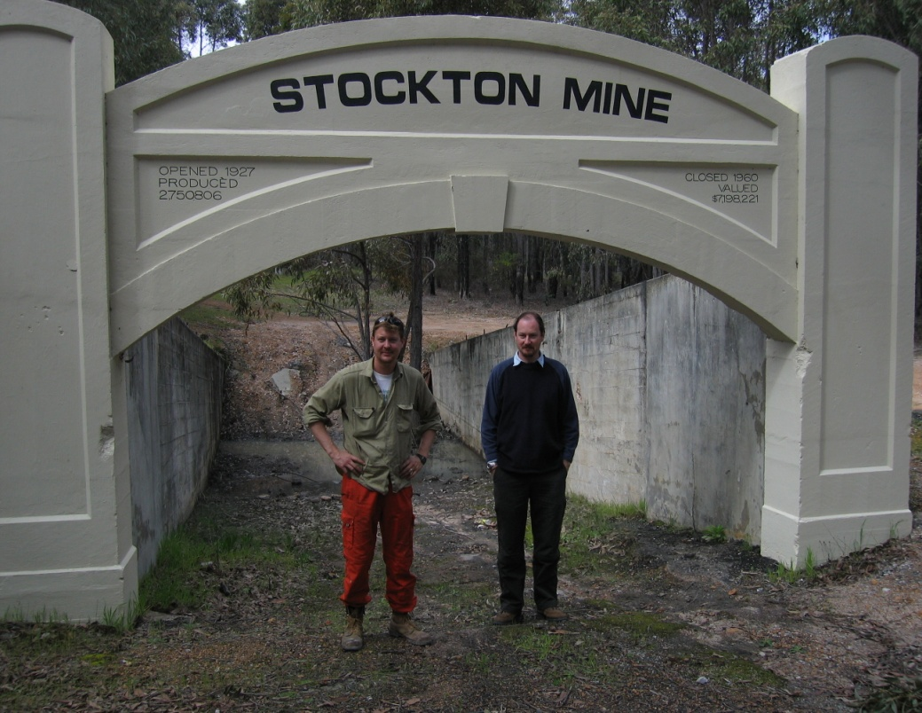
Figure 1 View of the historic Stockton underground mine near Collie/Western Australia.

Tables
All tables must be referenced at least once in the text, prior to their appearance. Your tables need to be formatted with only 3 horizontal lines: one above the table’s title, the second one below the table’s title and the third one at the end of the table (Table 1). Please remove all other horizontal or vertical lines to help us keep your tables as simple as possible. In many cases, simple tables can even be substituted by one or two lines of text, saving space for what you want to say.

Table 1 Comparison of submitted abstracts for the five most often selected conference themes at the IMWA 2010 Symposium.
Conference Theme | Submitted Abstracts | Countries
3 Mine Water Treatment – Active Systems | 34 | 9
1 Mine Water Issues & Innovative Mining Methods | 32 | 11
8 Mine Closure – Coal, Metal | 31 | 14
6 Analysis of Mine Water and its Chemistry | 29 | 13
4 Mine Water Treatment – Passive Systems | 27 | 10
Totals | 153 | 24

Conclusions
To write a properly formatted full paper (maximum 6 pages) for IMWA 2012, you should follow the instructions given above. If you fail to do so, a lot more effort will be required to reformat your text and this may make your document late for the final publication. Consequently, your paper may not be included in the proceedings volume. Only authors with full papers that appear in the proceedings volume will be given the opportunity to give an oral presentation during the symposium.

Acknowledgements
Thanks to Prof. T Rüde and Dr C. McCullough for their contributions to this document. The authors thank Edith Cowan University for hosting the IMWA 2012 Conference.

References
All references to publications made in the text must be presented in a list of references at the end of the text. Citation of references in the text should include the author’s name (without initial) and year of publication. Please use full journal names in references and follow the examples below for formatting.
Brown MC, Wigley TC, Ford, DC (1969) Water budget studies in karst aquifers. Journal of Hydrology 9:113—116
Caruccio FT, Geidel G (1984) Induced alkaline recharge zones to mitigate acidic seeps. In: Groves DH, DeVere RW (Eds), 1984 Symp of Surface Mining, Hydrology, Sedimentology and Reclamation, Univ of Kentucky, p 27—36
Gammons CH, Mulholland TP, Frandsen AK (2000) A comparison of filtered vs. unfiltered metal concentrations in treatment wetlands. Mine Water & Environment 19(2):111—123
Jennings JN (1971) An Introduction to Systematic Geomorphology – Vol 7, Karst. The MIT Press, Cambridge, Massachusetts, 252 pp

